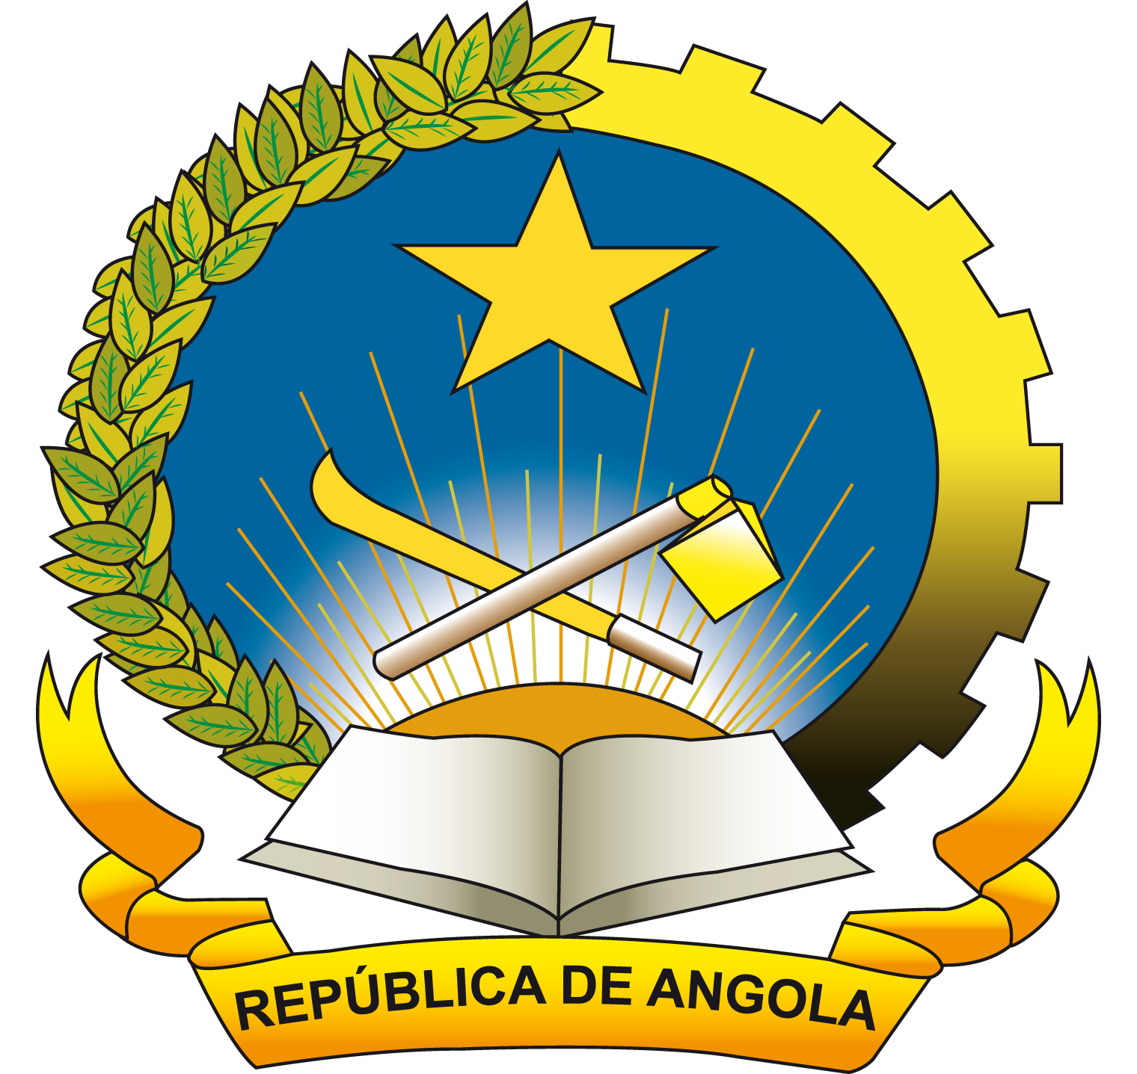
REPUBLIC OF ANGOLA

STATEMENT
BY
H.E. MRS. MARIA IDALINA DE OLIVEIRA VALENTE
MINISTER OF TRADE

SEVENTH MINISTERIAL CONFERENCE OF
WORLD TRADE ORGANIZATION

30/11 – 02/12/09
Geneva - Switzerland

Mr. Chairman,
Honourable Fellow Ministers,
Excellencies,
Ladies and Gentlemen,

In the first place, I would like to express my gratitude for the opportunity to address some words to this illustrious Ministerial Conference. I would like also to congratulate, Mr. Chairman, for your election to lead our works.

Mr. Chairman,

Eight years after the historical launching of the Doha Development Agenda, we acknowledge with certain concerns that the mandate given by the Members of the WTO, during 4th Ministerial Conference of Doha, has not been completely realized, in the matters of capital importance for the Development Countries in general, and of the Less Developed Countries in particular.

This fact involved the right appellation of “Round for the Development”, even more serious it questions, the credibility of the WTO as multilateral forum, capable/ to be able of solving satisfactory form the serious problems that its more vulnerable Members face.

We believe that the collective engagement taken in Doha, to place the interests and the necessities of the Developing countries in the Center of the Program of Work, will have, not only to be reaffirmed here in Geneva, in this 7th Ministerial Conference, but also to be materialized through the accomplishment of constructive progress and the fulfilment of commitments.

Mr. Chairman,

The Republic of Angola, that today lives in Peace, considers that the liberalisation of trade can have a positive effect in the economic growth, and recognizes the imperiousness of the integration of trade in national strategies to gradually eradicate poverty, contributing of this form to the sustainable development, and the general objectives of the Millennium Declaration.

However, we also have a full conscience that the opening of markets does not constitute, by itself, the definitive solution to the innumerable political, economical, financial and social problems with which Africa is still confronted, especially since positive results obtained by the African Countries in recent years, promoting its economic and social development, are being affected by the recent economic and financial crisis.

The African Bank of Development esteems that the export losses for our continent will be of more than 259 billions of American dollars in 2009 and might reach more than 277 billions USD in 2010.

Mr. Chairman,

Although this Ministerial Conference is not a session for trade negotiations, please allow me to enhance and remember some points of extreme importance to the Less Developed Countries, of which my Country belongs.

In this year, different international Summit, namely the G-8 in Aquila (Italy) and G-20 in Pittsburgh (USA), many were the political declarations, made to strengthen the support to the less developed countries facing the unfavourable consequences of the current global crisis, as well as to conclude ambitiously the Doha Development Agenda.

These declarations - that we satisfactory register - can only be credible if in fact, they are expressed in negotiation positions and concrete flexibilities.

In this context, I would like to underline one more time that a “precocious solution” must be found with respect to the duty free quota free market access in accordance with the Hong Kong Ministerial Declaration, as well as reminding the necessity to eliminate all the distorsive measures to trade.

The initiative of “Aid for Trade” is not part of the “single undertaking”, and therefore its implementation does not have to be conditioned to the adoption of a global package of engagements in the negotiation matters of the Doha Development Agenda, for what we reiterate the necessity of materializing the commitments assumed in Hong Kong and the conclusions of 2nd global review.

Mr. Chairman,

The current financial and economic crisis evidences that we are all in the same boat.

Therefore, we appeal to all the Members of the WTO, and in particular to the Developed Countries, to give a more effective and concrete support in order to find fair solutions for the accurate accomplishment of the deepest aspirations of the Developing countries and the LDC with the aim of its harmonious insertion in the multilateral trade system.

We would not like to finish without stating that the Republic of Angola associates its voice to the LDC, African Group and ACP Declarations. A balanced Conclusion of the Doha Round, will constitute, unquestionably, a valuable contribution for the solution of referenced difficulties.

Thank you very much

